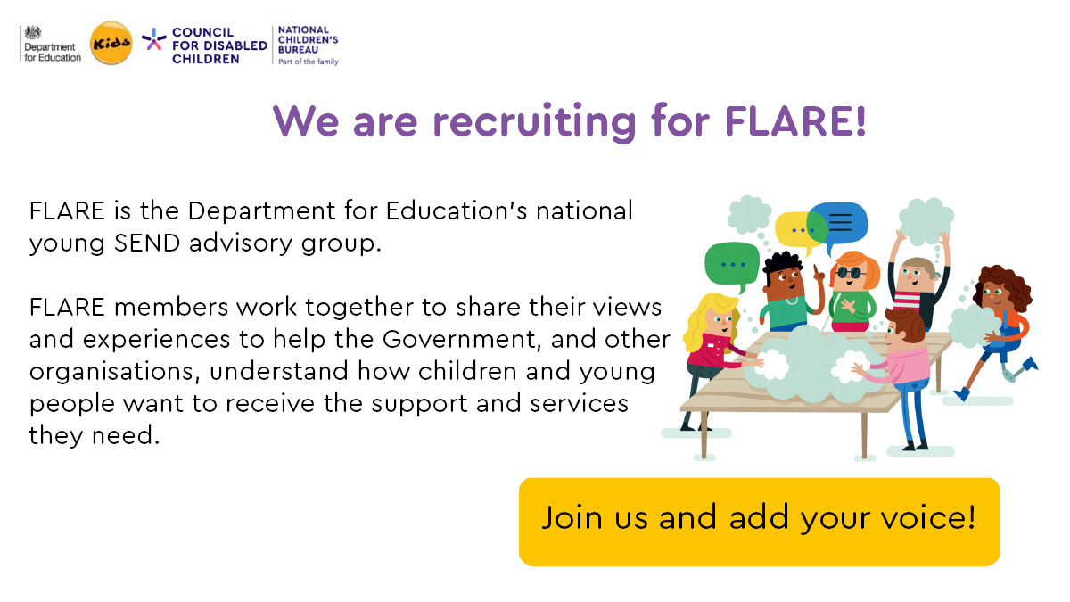
Join our Youth Advisory Group to have your say and share your views!
The Council for Disabled Children are looking for disabled young people and young people with special educational needs (SEN) aged 12-18 to our young people’s advisory group FLARE. FLARE stands for Friendship, Learning, Achieve, Reach and Empower.
What is the Youth Advisory Group?
The group will represent the views and voices of young people with special educational needs and disabilities all over England.
The group will work together to share their views and experiences to help us understand how disabled children and young people and those with SEN want to receive the support and services they need.
Your advice and sharing will help the Council for Disabled Children to understand how changes to support are affecting disabled children and young people’s lives.
You will:
- Share your experiences and expertise
- Give feedback and advice
- Talk to professionals about how to make positive changes to improve things for all disabled young people
- Take part in 6 meetings a year
Why should I get involved?
CDC thinks it is important that disabled children and young people and those with SEN have a say in how they are supported and in the services that are available to them.
We want to make sure that all disabled children and young people can be involved in decisions about their care and support.
What will you gain?
- Get to meet and work with new people
- Get to share your views and ideas
- Gain new skills
- Help to make support and services reflect what disabled children and young people think
We will pay your travel expenses to take part in meetings

How do I get involved?
If you are interested in joining you will have to submit a short application telling us a bit about you. The application form is below.
We also accept video applications, or you can call us and set up a time to arrange and talk to us.

Please send your applications to Ga-Ling at ghardstaff@ncb.org.uk by Friday 19th May at 5pm.
Young People’s Advisory Group Application Form
Name: |  | Telephone number:
Address: |  | Date of birth:
Phone number: |  | Email address:
Which method do you refer to be contacted by? |  | Phone: | Email:
Do you have access to a computer? |  | Yes: | No:
About you
For this section, we want to hear about you. There are limited spaces for the group and unfortunately not everyone who applies will get a place, so please give us as much information about yourself as you can in your application. You can use extra sheets if you need to.
Please tell us a bit about you!
If you are feeling a bit stuck why not answer a couple of these questions: why you want to be part of the group, and why you think it is important to listen to disabled children and young people.
There is no right or wrong answer, we want to hear what you think! Write as much as you’d like.

