Disabled young people and young people with special educational needs wanted for advisory group
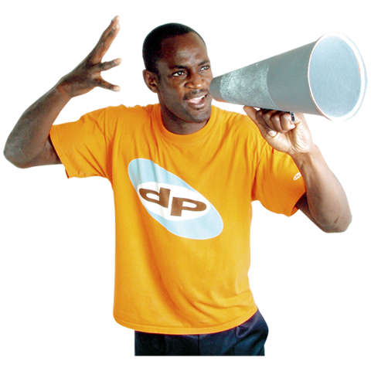
- Are you a disabled young person or a young person with special educational needs aged 12 – 18?
- Do you live in England?
- Do you want to help make lives better for other young people
- Do you like having your say and sharing your views?
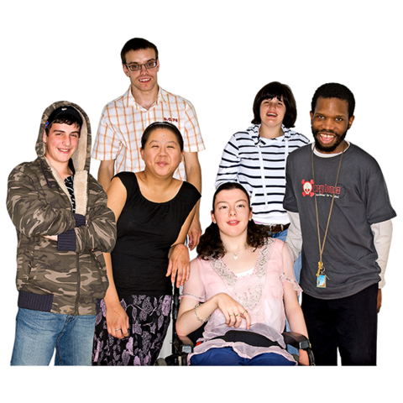
We want to hear from you!
We want disabled young people and young people with special educational needs to join FLARE.
FLARE stands for Friendship, Learning, Achieve, Reach and Empower.
FLARE is for 12 - 25 year olds.
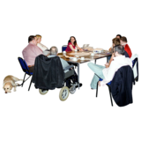
About our new group
The group will meet in London 6 times a year.
The young people will give advice on local support and services.
Not everyone who applies will get a place.
If you join our new group, you will:
- Share your experiences and expertise

- Give your views and advice
- Talk to adults who work with young people and share how to make things better for all disabled young people and those with special educational needs
You will need to
- Come to 6 national group meetings in London a year
- Share thoughts and ideas with adults in big meetings and in small groups
- Work together with both adults and young people

Why you should get involved
We want lots of disabled children and young people and children and young people with special educational needs to tell us how they like to make choices and how to make things better for other children and young people.

What you will get from the group
- Get to meet and work with new people
- Get new skills
- Help to make sure adults know what is important to disabled children and young people and children and young people with special educational
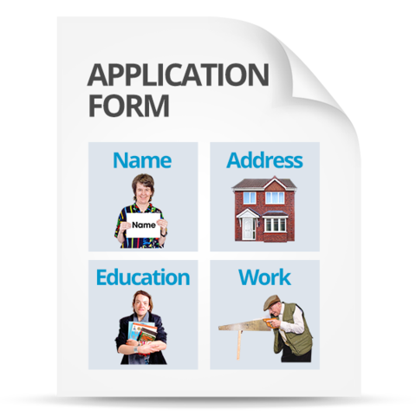
We will pay your travel expenses to take part in meetings.
How you can get involved
If you want to be part of the group you will have to fill in a short application to tell us a bit more about you. The application form is below.
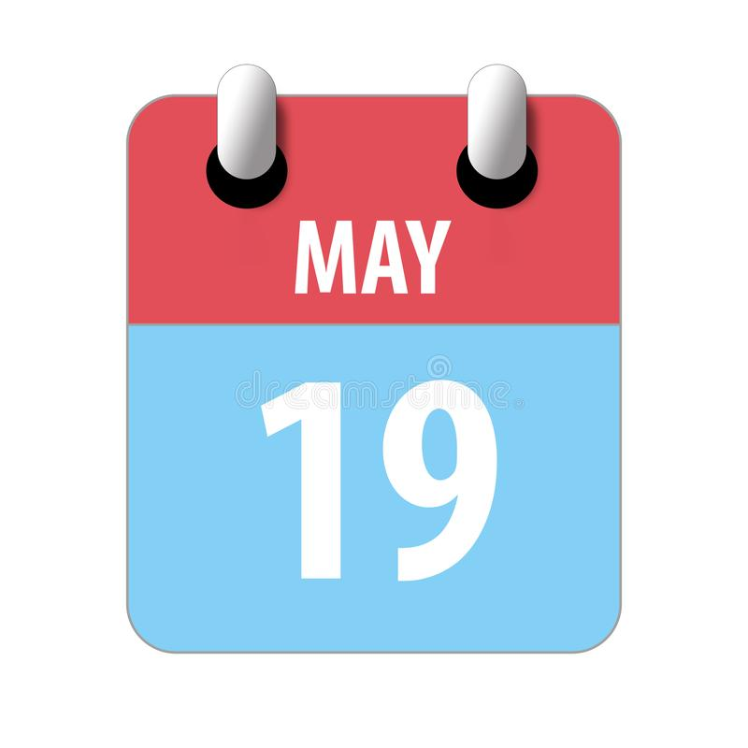
The closing date for applications is Friday 19th May at 5pm.

Young People’s Advisory Group Application Form
You can:
Write your answers in the box, or you can answer the questions in a short film.
Remember to give your full name and contact information and answer all the questions.

You need to send your completed application to Ga-Ling Hardstaff. Her e-mail address is ghardstaff@ncb.org.uk

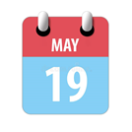
Send your application to Ga-Ling by Friday 19th May 5pm.
If you have any questions please contact Ga-Ling 07802465985 or ghardstaff@ncb.org.uk

About You
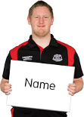
Name

Address
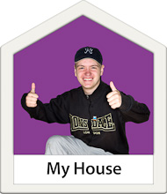

Date of birth
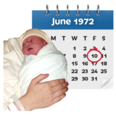


Phone number

Email address


Do you like phone or e-mail better?  or | Phone Email
Do you have a computer? | Yes No
About you
There are no right or wrong answers. We want to know what you think!
Please give us as much information about yourself as you can in your application.
You can use extra sheets if you need to.
If you are a bit stuck why not answer a couple of these questions: why you want to be part of the group, and why you think it is important to listen to disabled children and young people.

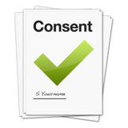
Consent
I am happy to take part in the Young People’s Advisory Group and to be contacted about the group.
Name:
Sign:
Date:

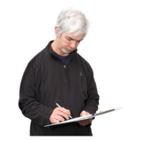
If you are under 18, you will need your parent or guardian’s permission to take part in the group
Name:
How do you know the young person:
Sign:

Date:

CDC has lots of opportunities for young people to share their thoughts and ideas. Would you like CDC to keep your name and address and send you information about other opportunities?
Please tick one
I agree that you can contact me about other opportunities
I do not want you to contact me about other opportunities
This information has been made with Photosymbols.


