Application From - Advisory group for young people who have learning disabilities and/or are autistic

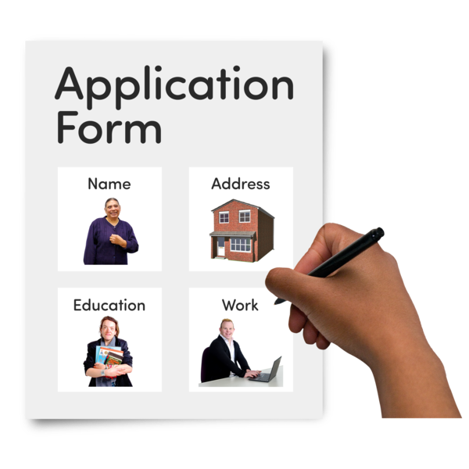 | If you would like to join the Advisory Group, please complete this short application form.  The form is below.
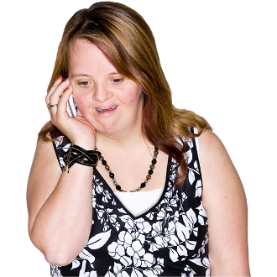   | You can send us a video, or arrange a phone call instead of filling in the form.
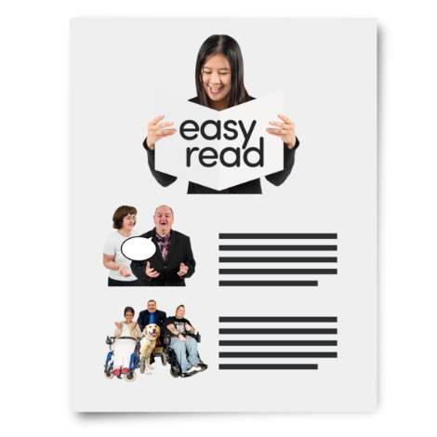 | To learn more about what you would do in the Advisory Group click here for an information sheet.
   | You need to email your application to Hope at hcapurro@ncb.org.uk by the  10th of October 2022
Application Form
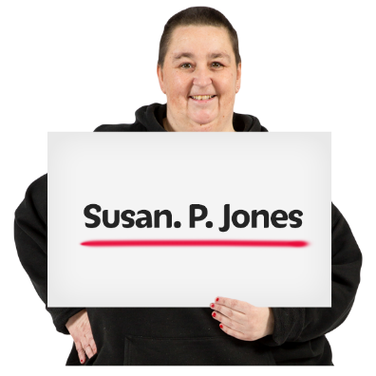 | Your name:
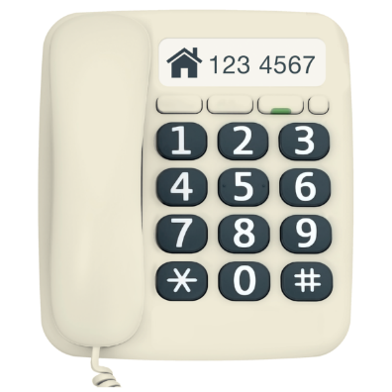 | Your home telephone number:
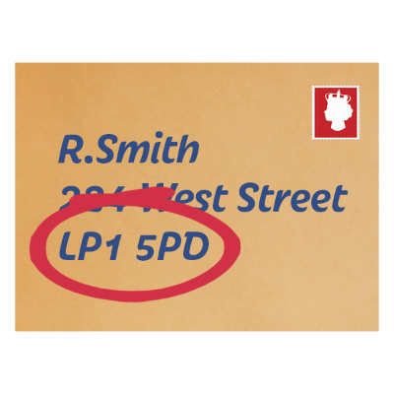 | Your address:
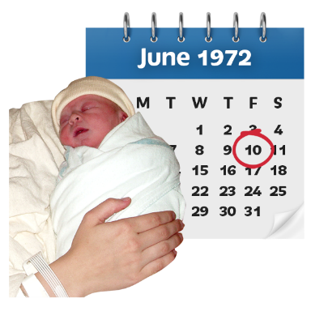 | Your date of birth:
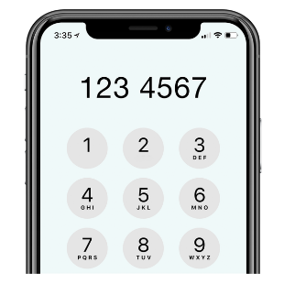 | Your mobile phone number:
 | Your email address:
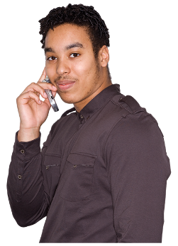   | Do you prefer to be contact by phone or by email?
 | Do you have access to a computer?

About you
 | We want to hear about you.  There are limited spaces for the group so not everyone who applies will get a place.
 | Give us as much information about yourself as you can in your application.
 | You can use extra sheets if you need to.
 | Remember, instead of writing, you can record yourself in a video, or set up a time to talk to use on the phone.
 | Tell us about you.
 | Tell us why you want to be part of the group,
 | Tell us why you are passionate about young people’s mental health support.
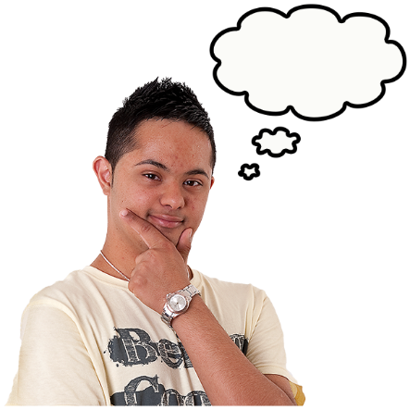 | There is no right or wrong answer, we want to know what you think.  Write as much as you would like.

Write here:

